1) Open Terminal ctrl+alt+t:
2) Type as below:
sudo -i -u postgresql
3) Then type as below:
psql
4) To list all databases:
\l
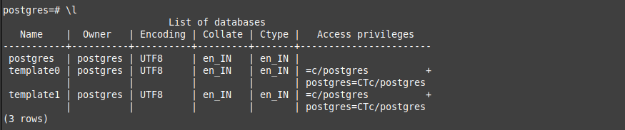
5) To Create Database:
create database MovieDB;
6) To switch to newly created database:
\c movie
Other Way to Connect to newly created database:
psql movie
7) To know version of postgres:
select version();
8) To know current date:
select current_date;
9) The psql program has a number of internal commands that are not SQL commands. They begin with the backslash character, “\”. For example, you can get help on the syntax of various PostgreSQL SQL commands by typing:
To quit:

SQL Language:

1. Create Table:
create table movie
(
movie_name varchar(80),
release_date date,
ticket int
);

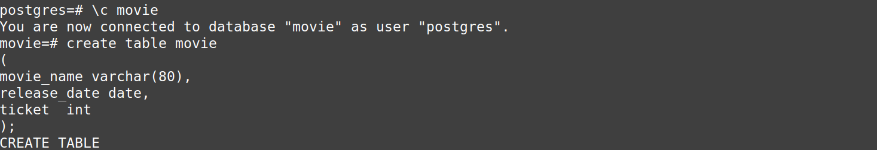
Note:
1) Two dashes (“--”) introduce comments. Whatever follows them is ignored up to the end of the line.
2) SQL is case insensitive about key words and identifiers, except when identifiers are double-quoted to preserve the case (not done above).

Datatypes:
1) varchar, char
2) int, smallint, numeric
3) real, double
4) date, time, timestamp
5) point [postgresql specific datatype]

insert

Populating a Table with rows:
insert into movie values('varisu','2023-01-15', 120);
insert into movie values('thunivu','2023-01-15', 120);
An alternative syntax allows you to list the columns in different order explicitly:
insert into movie (release_date, movie_name, ticket) values ('2023-01-10','dada', 120);
insert into movie(movie_name, ticket) values ('ayothi',120);
Querying a Table:
select * from movie;
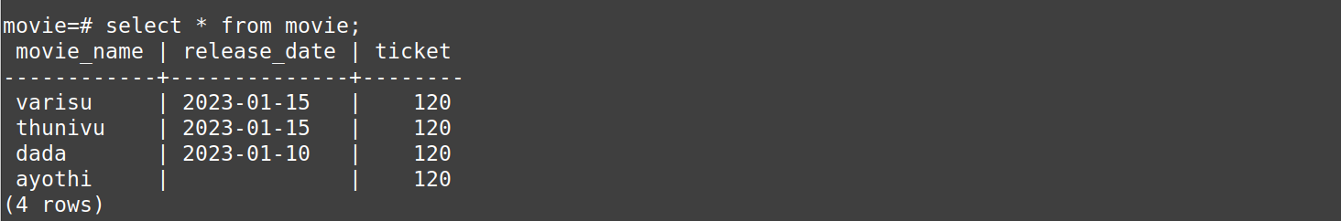
Here * is a shorthand for “all columns”.
So the same result would be had with:

select movie_name, release_date, ticket from movie;

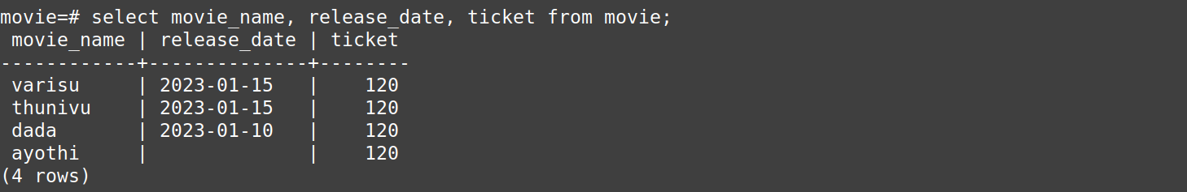
We can write expressions, not just simple column references, in the select list.

Select movie_name, release_date, ticket*4 as family_price from movie;

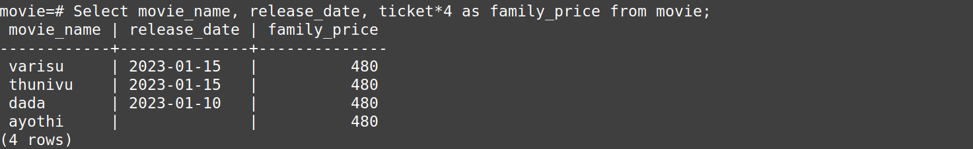
Task #2:

1) Create a Table Called Employee:
2) To get details about table columns:
3) Insert two employee details:
4) Add more rows in single insert statement:
5) Get all details we entered:
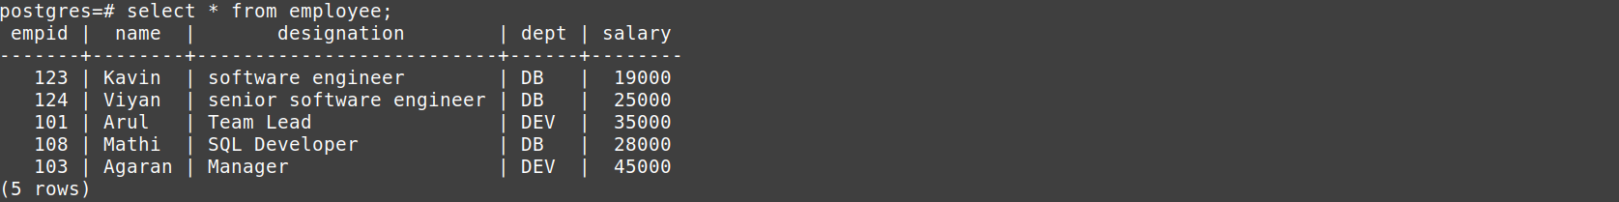
6) Specific column values:
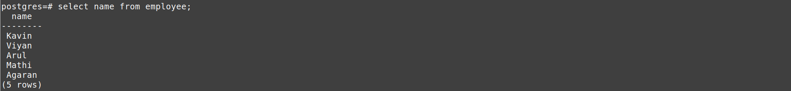
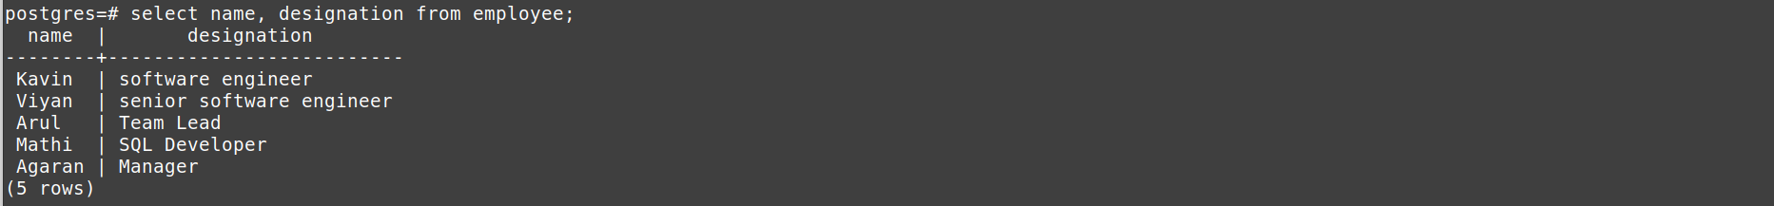
7) Change Table Name:
8) Add more rows:
Learnings: Select:
#1: select distinct
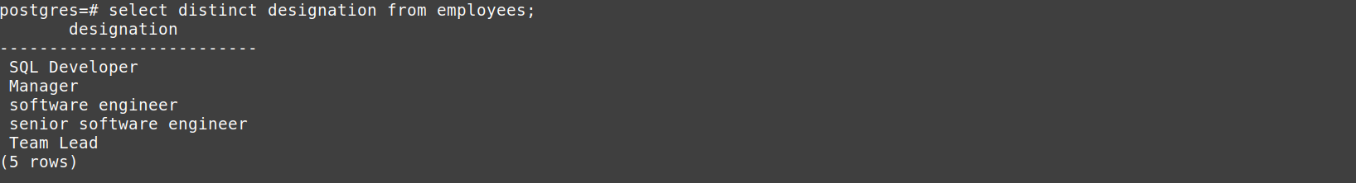
#2: where clause:
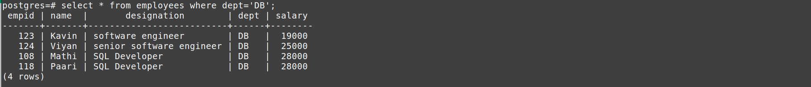
#3: where, and
#4: where, or:
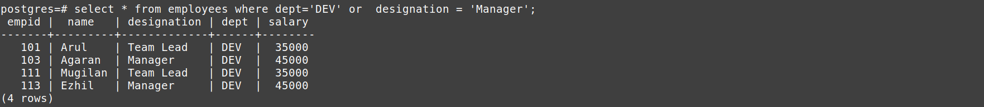

#5: as

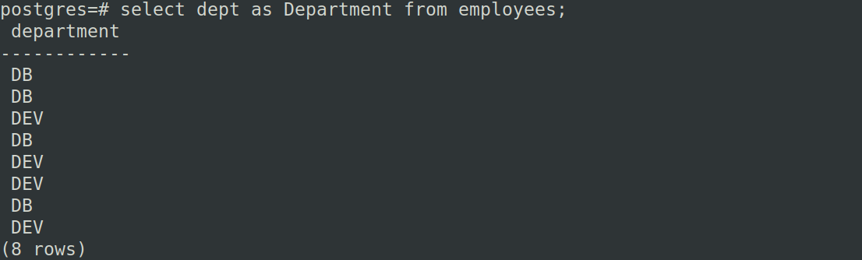
#6: Not Equals to:
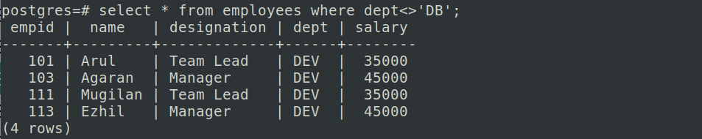
#7: > greater than:
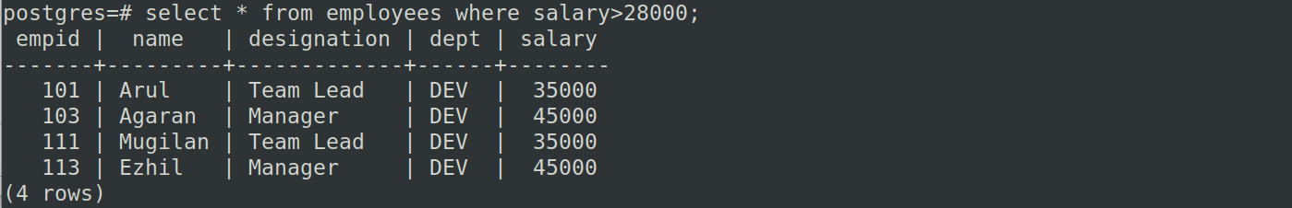
#8: between:
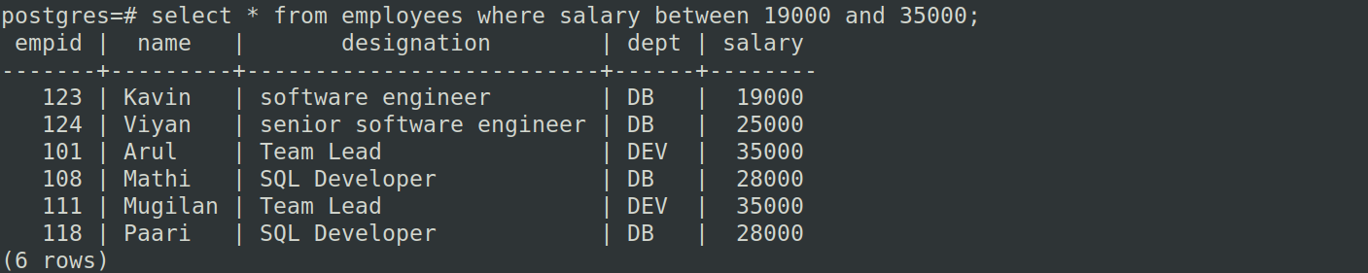
#9: in
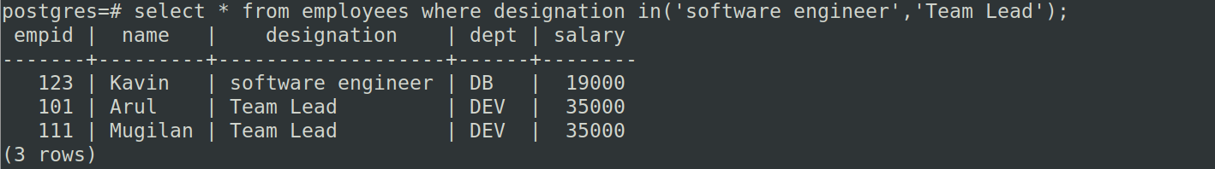
#10: and
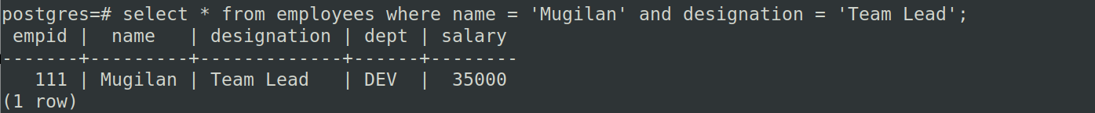

#11: or
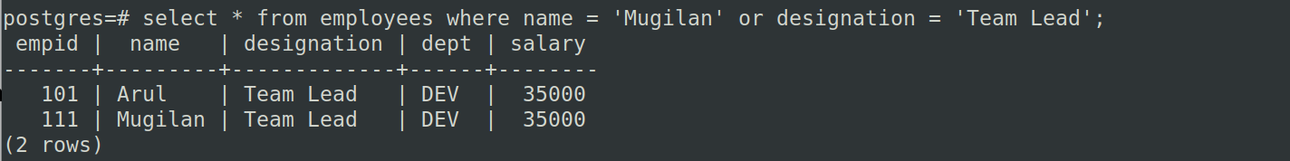
#12: not
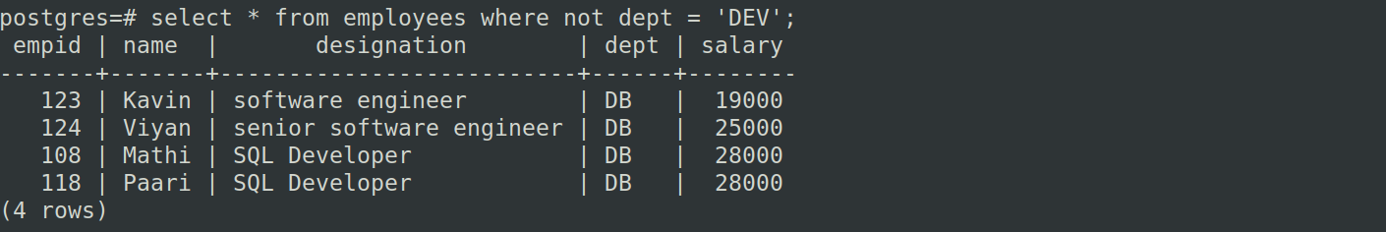
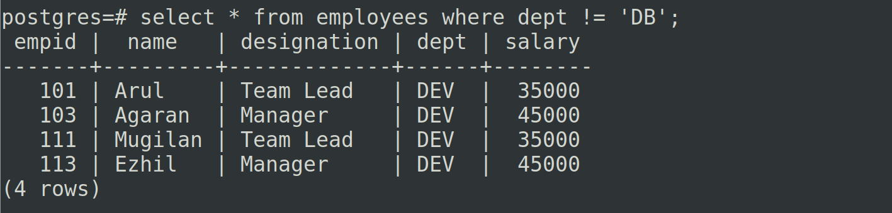
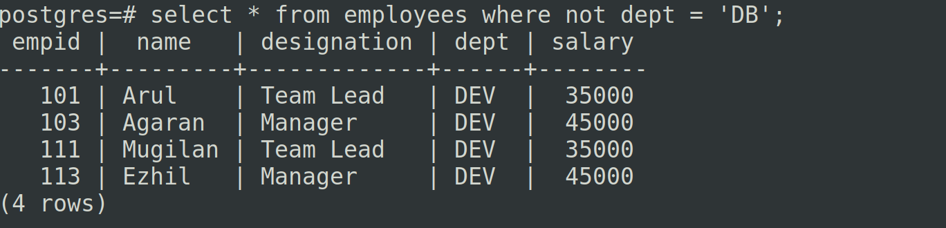
#13: and, or
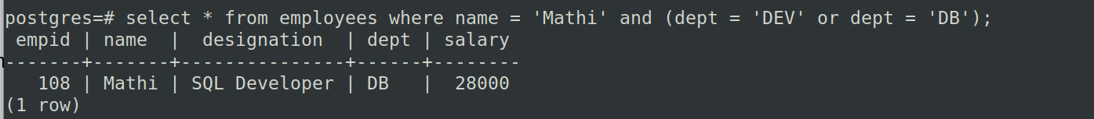
#14: not, in
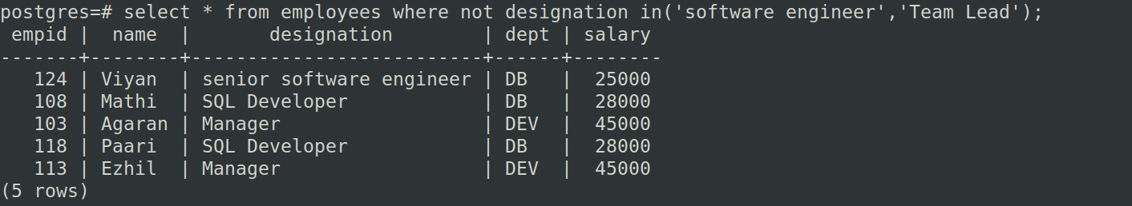
#15: order by:
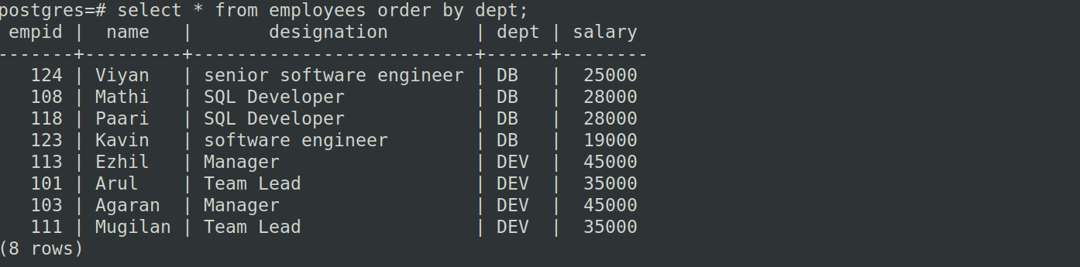
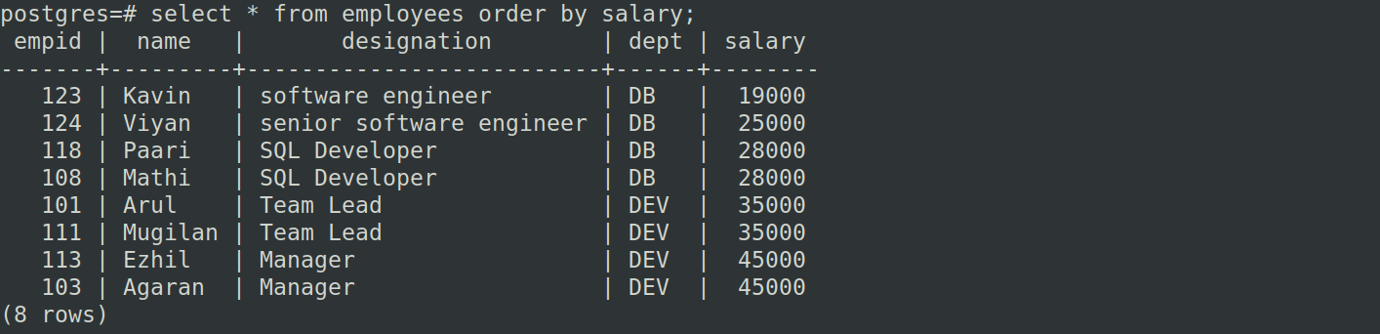

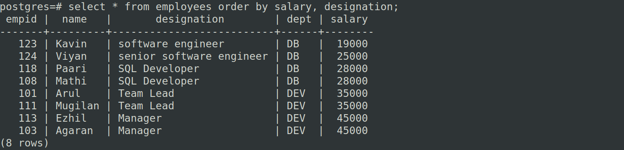

#16: order by desc:
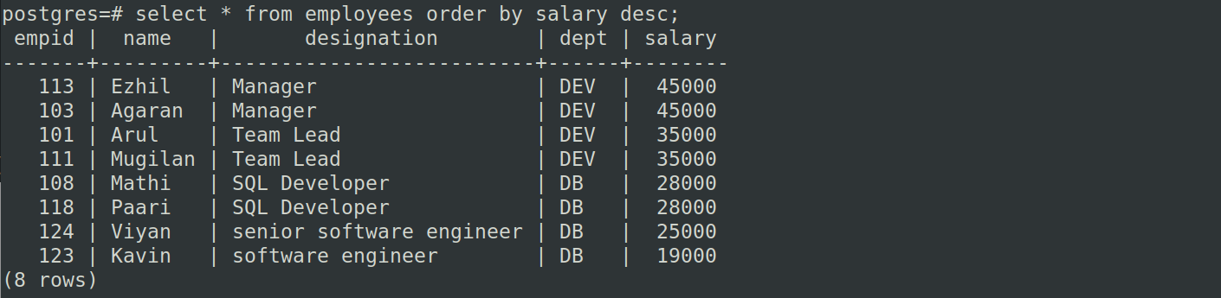
#17: desc, asc:
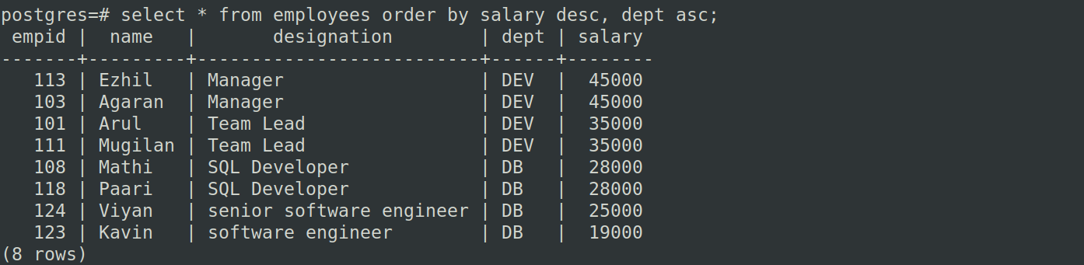
#18: limit:

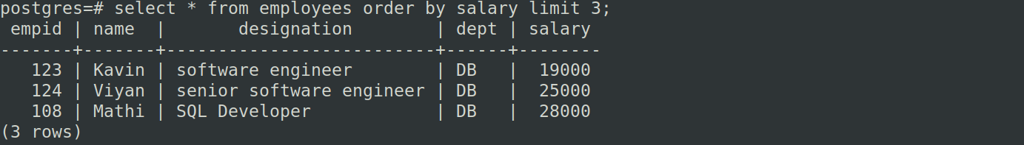
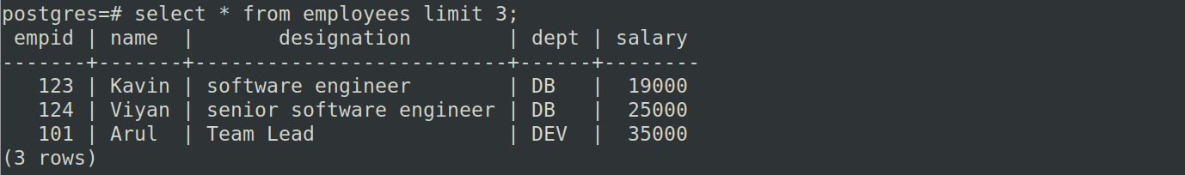
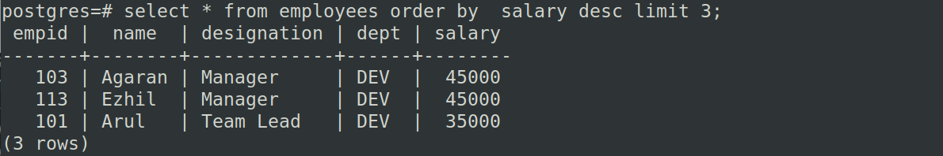

#19: fetch:
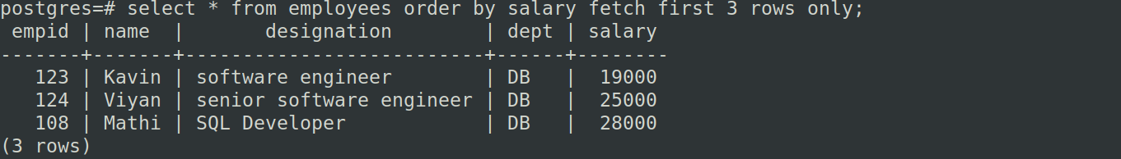
#20: LIKE Operator:

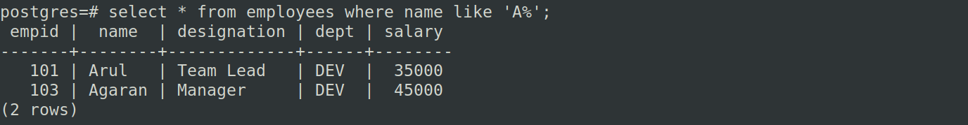
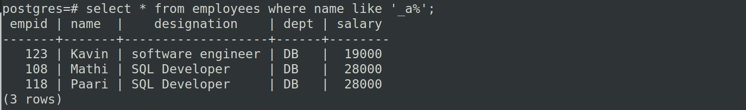
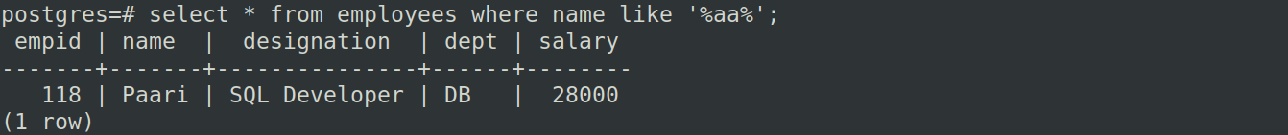
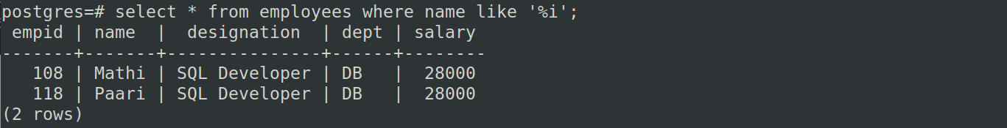
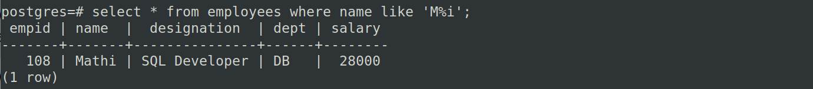
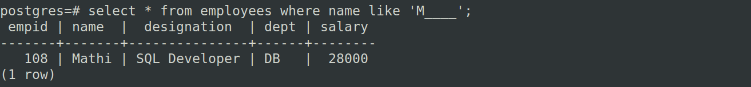

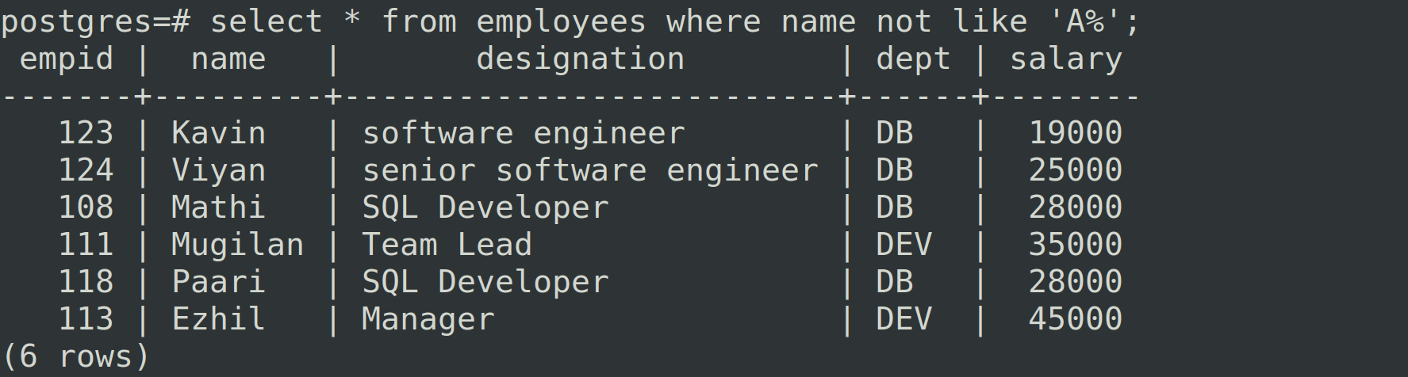
Aggregate Functions:
#1 min:
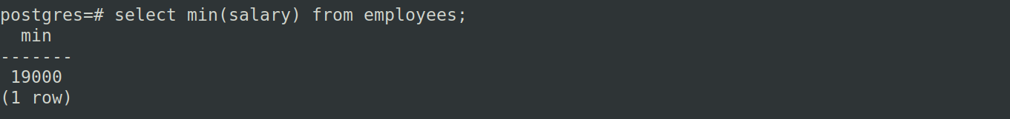
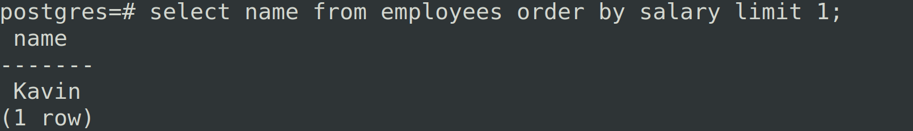
Sub query:
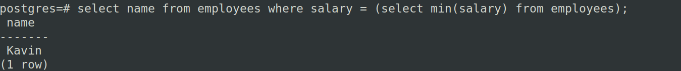
#2: max:
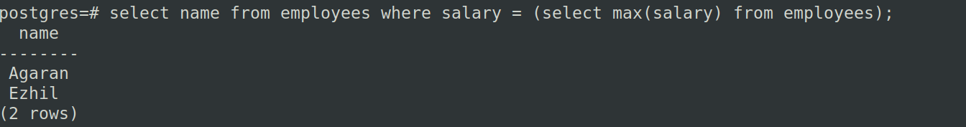

Count, Avg, Sum:
#1: count:
#2: avg:
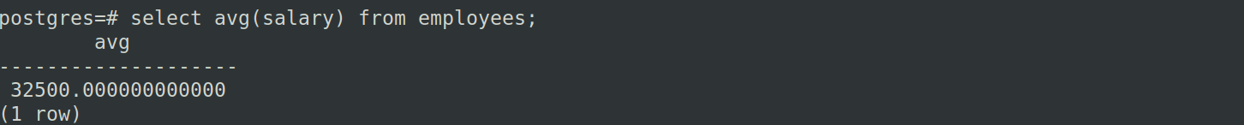
#3: round
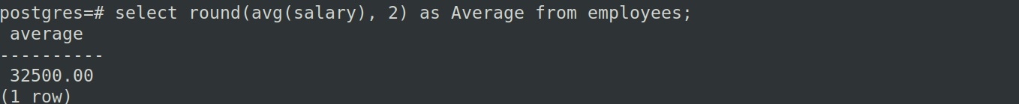
#4: sum
Second Max:
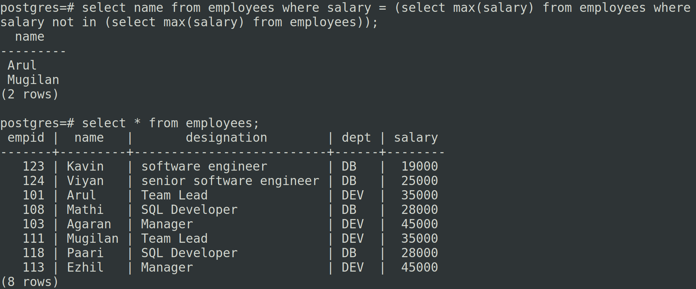
Group By:
#1:
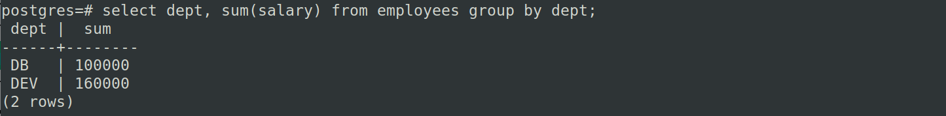

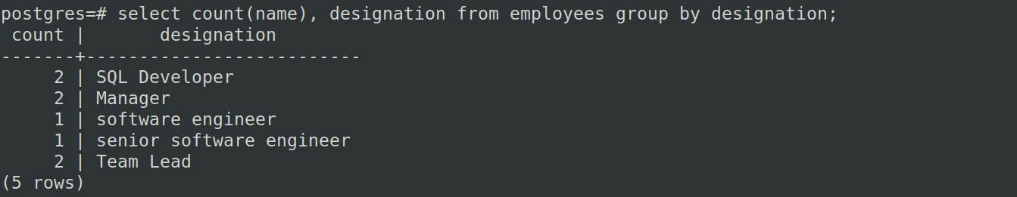
Group By and Order By:
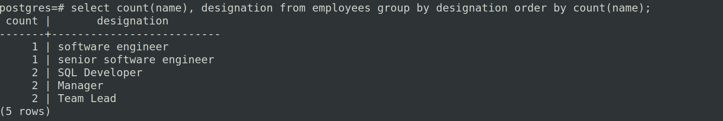
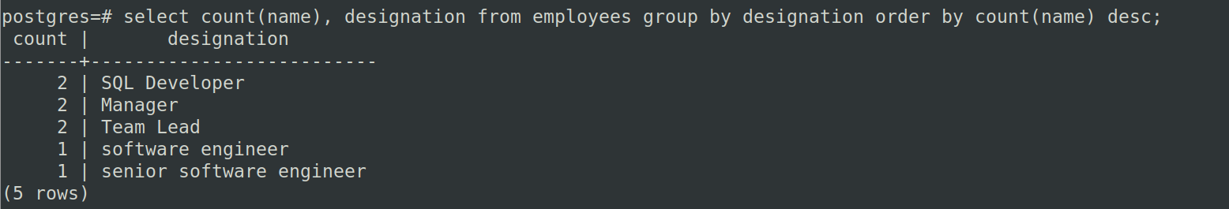
Having:
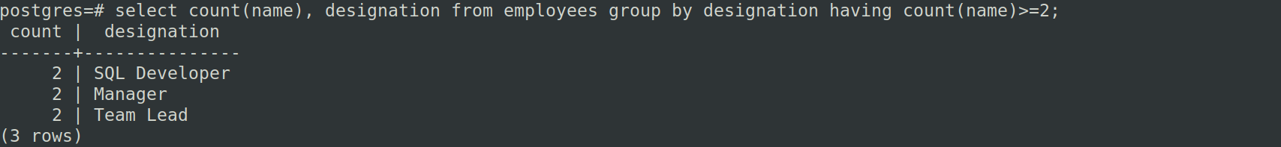
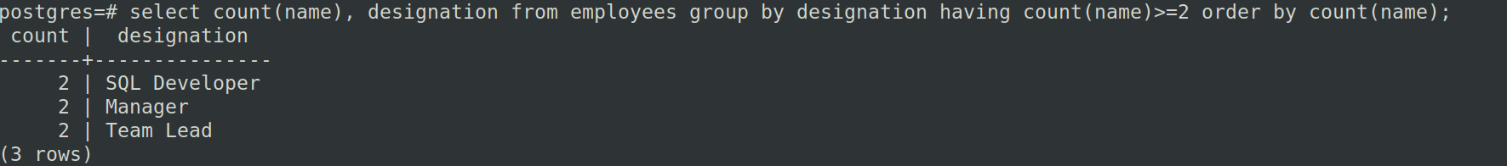
Joins:
Team:
TeamID | PlayerID | Joined_Date
101 | 1 | 31-03-2023
201 | 2 | 30-03-2023
301 | 3 | 01-04-2023
create table team
(
team_id int,
player_id int,
joined_date date
);
insert into team values(101,1,'31-03-2023');
insert into team values (201,2, '30-03-2023'), (301, 3, '01-04-2023'), (401, 4, '01-04-2023');
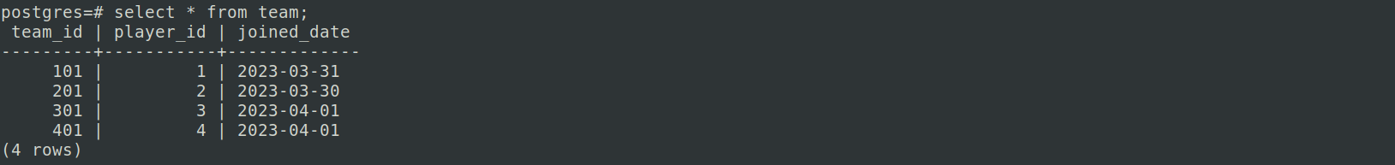
Player:
PlayerID | PlayerName | TeamName | Country
1 | Dhoni | CSK | India
2 | Warner | Delhi | Australia
3 | Buttler | Rajasthan | England
create table player
(
player_id int,
player_name varchar(20),
team_name varchar(20),
country varchar(20)
);
insert into player values (1, 'Dhoni', 'CSK', 'India'), (2, 'Warner', 'Delhi', 'Australia'), (3, 'Buttler', 'Rajasthan', 'England');
insert into player values (4, 'Kohli', 'KKR', 'India'), (5, 'Rohit', 'Hyderabad', 'India'), (6, 'Jadeja', 'Rajasthan', 'India');
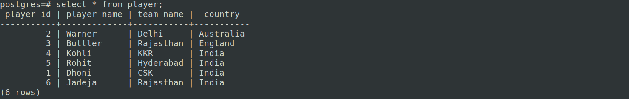
Inner join:
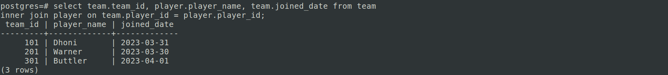

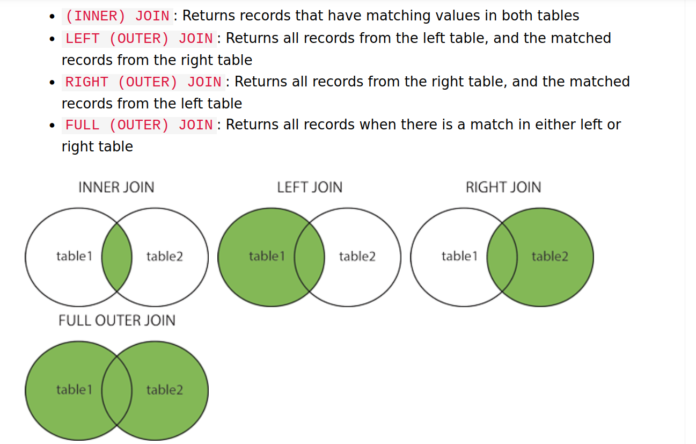
Courtesy: w3schools.com

Left Join:

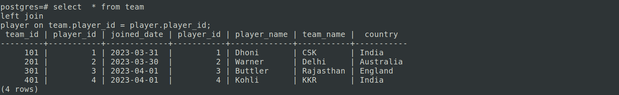

Right Join:
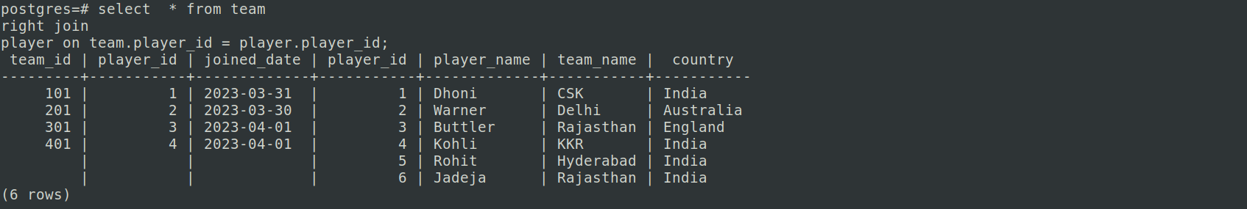
Left Join with Exclusion:
Full Outer Join:
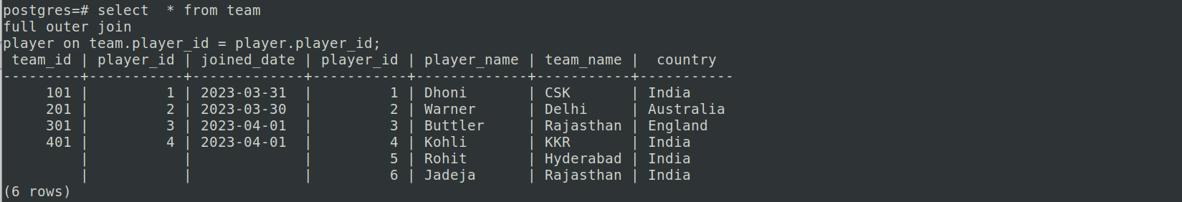
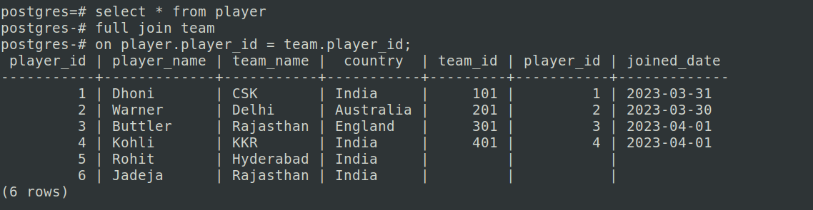
Join with more than two tables – Sample:
SELECT
student.first_name,
student.last_name,
course.name
FROM student
JOIN student_course
ON student.id = student_course.student_id
JOIN course
ON course.id = student_course.course_id;

Union:
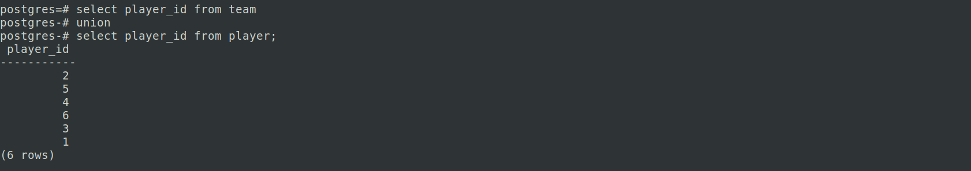
Union All:
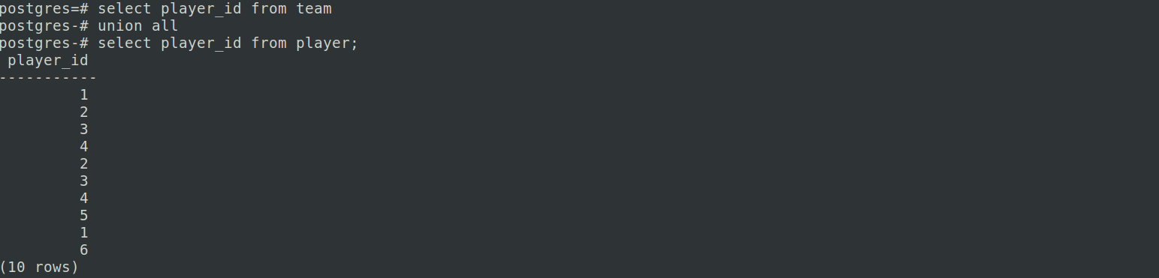
Intersect:
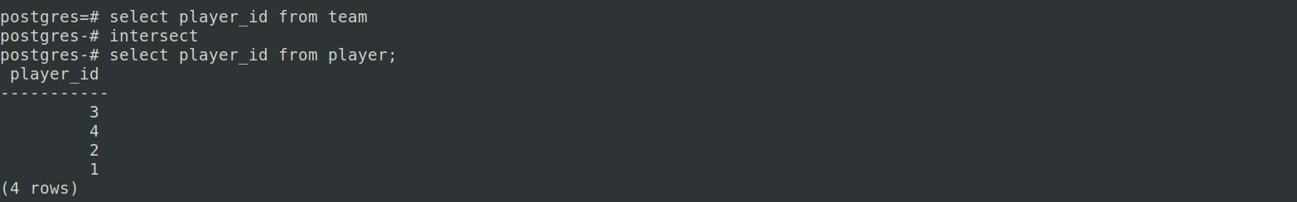
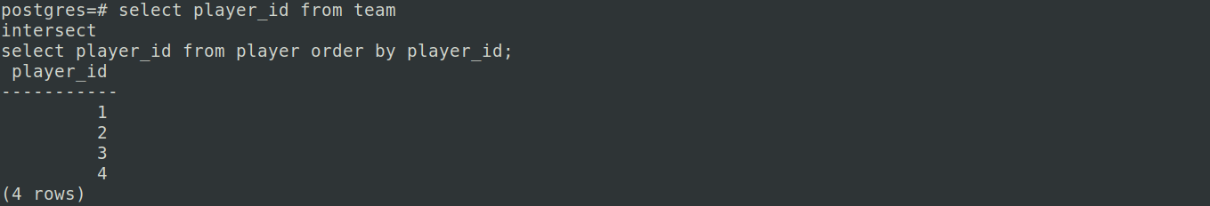

Constraints:
1) Check Constraints:
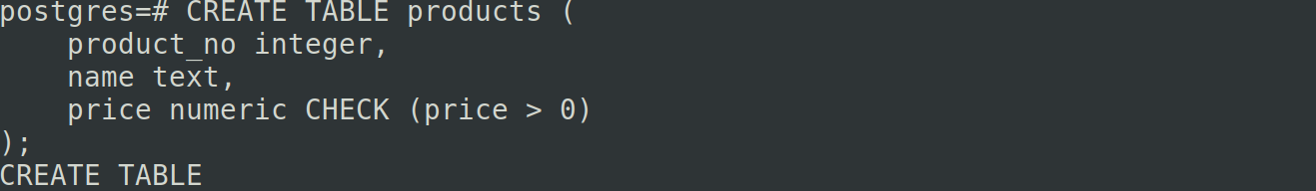
Separate Constraint Name:
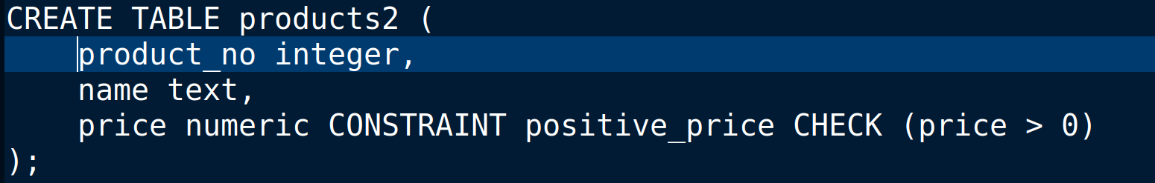
to specify a named constraint, use the key word CONSTRAINT followed by an identifier followed by the constraint definition. (If you don't specify a constraint name in this way, the system chooses a name for you.)

A check constraint can also refer to several columns. Say you store a regular price and a discounted price, and you want to ensure that the discounted price is lower than the regular price:

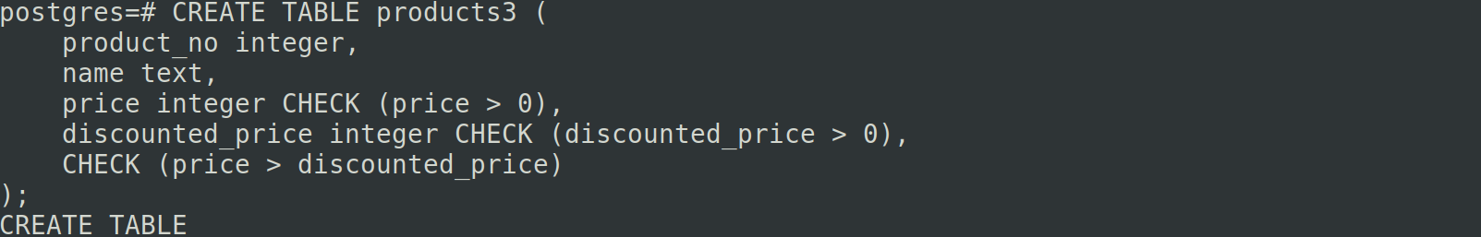
Not Null Constraint:
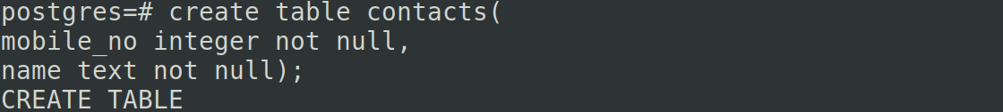

Can we have more than one constraint?

CREATE TABLE products (
product_no integer NOT NULL,
name text NOT NULL,
price numeric NOT NULL CHECK (price > 0)
);
The order doesn't matter. It does not necessarily determine in which order the constraints are checked.

Unique Constraint:

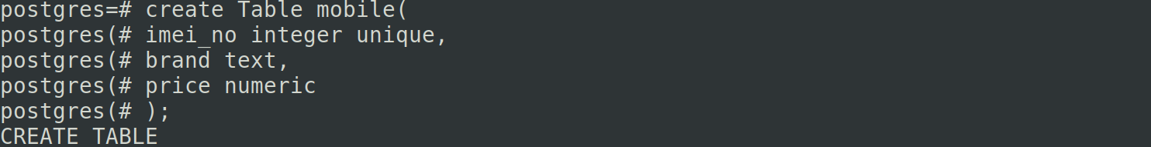
The above can be rewritten as:
create Table mobile(
imei_no integer,
brand text,
price numeric
unique (imei_no) );

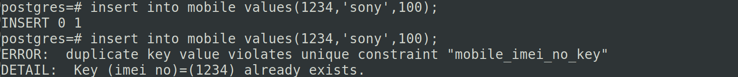
Multiple Constraints:
create Table mobile(
imei_no integer,
sim_no integer,
brand text,
price numeric
unique (imei_no, sim_no)
);

Primary Key:
A primary key constraint indicates that a column, or group of columns, can be used as a unique identifier for rows in the table. This requires that the values be both unique and not null.

CREATE TABLE products (
product_no integer UNIQUE NOT NULL,
name text,
price numeric
);
CREATE TABLE products (
product_no integer PRIMARY KEY,
name text,
price numeric
);
Can we keep more than one column as primary key?
Yes.

CREATE TABLE example (
a integer,
b integer,
c integer,
PRIMARY KEY (a, c)
);
Foreign Key:
CREATE TABLE products (
product_no integer PRIMARY KEY,
name text,
price numeric
);
CREATE TABLE orders (
order_id integer PRIMARY KEY,
product_no integer REFERENCES products (product_no),
quantity integer
);
CREATE TABLE orders(
order_id integer PRIMARY KEY,
product_no integer REFERENCES products,
quantity integer
);

Views:
Views are kind of virtual tables. Every time a view is used, it executes its stored query and creates a result set consisting of rows and columns.

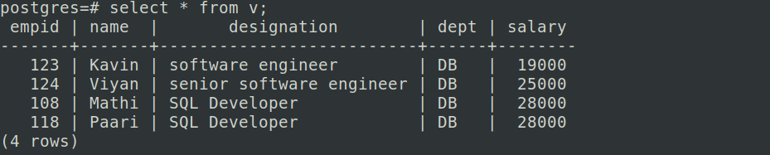

We can create views from multiple tables also.

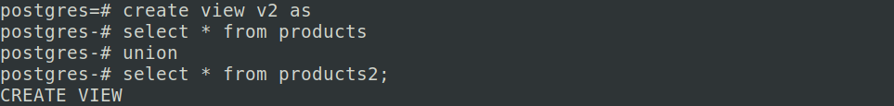

To Delete view:
Difference between View and Table:
A table (concrete table) stores its data in columns and rows in the database. A view (virtual table) is built on top of the concrete table(s) it fetches data from and does not store any data of its own in the database. A view only contains the SQL query that is used to fetch the data.
To summarize, the result set of a view is not materialized on the disk, and the query stored by the view is run every time we call the view.
INDEX:
CREATE INDEX constructs an index on the specified column(s) of the specified relation, which can be a table or a materialized view. Indexes are primarily used to enhance database performance (though inappropriate use can result in slower performance).

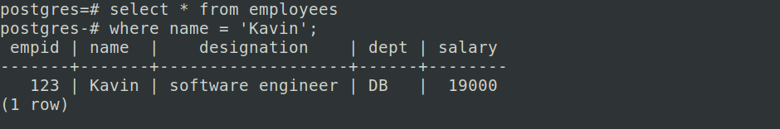
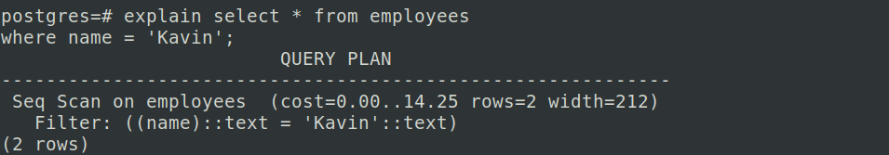
Now, create index as:
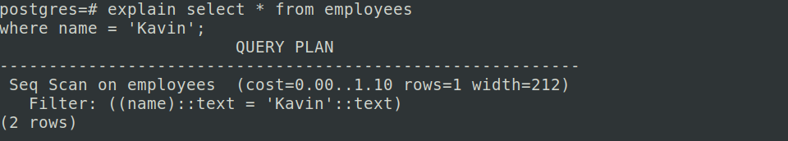
DML:

References:
https://www.postgresql.org/docs/current/ddl-constraints.html
https://www.postgresqltutorial.com/postgresql-tutorial/postgresql-natural-join/
https://www.w3schools.com/SQl/sql_where.asp
https://learnsql.com/blog/sql-view/
https://learnsql.com/blog/how-to-join-3-tables-or-more-in-sql/

